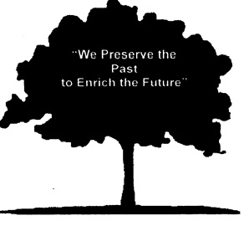  For Immediate Release | St. Cloud Area Genealogists  Contact: Brendon Duffy  320-237-3023  duffyroots@gmail.com

Quick Facts:
Program: St. Cloud Area Genealogists
Date: Tuesday, November 15, 2022 at 7:00 p.m. (CST)
Cost: Free for members, $7 for non-members (to register email kmsauer@ymail.com)
Location: Online and at Stearns History Museum
Facebook: @stcloudareagenealogists
Adding Leaves and Flowers to the Branches of Your Family Tree

St. Cloud –A common problem for genealogists is making their research interesting enough that others will want to read about it. Genealogist Linda Coffin will address this challenge in her workshop “Adding Leaves and Flowers to the Branches of Your Family Tree” for the St. Cloud Area Genealogists on Tuesday, November 15, 2022 at 7 p.m. at Stearns History Museum (235 33rd Ave S., St. Cloud). The presentation will be offered synchronously online. Coffin will provide ideas for turning your charts and tables into interesting narratives, complete with illustrations and historical context. We will discuss types of background information that can be added to your stories and review examples. You don’t need to be a talented writer to liven up your genealogical stories. You will leave feeling more confident you can do it!

Linda Coffin has 35 years of experience as a self-employed graphic designer. In 2004, she started her own business, HistoryCrafters (www.historycrafters.com), to help her clients preserve memoirs and family histories and publish them as short-run books. To date, she has worked on more than 40 such books, for individuals, families, businesses, and even a golf course! Linda is a member of the Minnesota and Wisconsin Genealogical Societies, the National Genealogical Society, and the Association of Professional Genealogists. She has presented at many local, state, and national genealogy and memoir conferences.

St. Cloud Area Genealogists
Founded in 1973, the St. Cloud Area Genealogists is a non-profit organization that strives to make family history research an enriching and rewarding experience. This premier organization is for everyone from the beginner to the most advanced family historian. Our members research their ancestors from varying locations within Minnesota, throughout the United States, and from foreign countries.

###

